# 

Table of contents

Overview 2

Registration and account settings 2

Step 1 - Sign-up 2

Step 2 - Verify your email address 3

Step 3 - Log-in 4

Step 4 - Complete your account information (optional) 5

Pages 8

Home page 8

Calendar 8

Overview 10

What’s New 11

Events page 12

Event page 15

Header 15

Comment section 17

Payments section 18

Users page 19

Wishlist page 20

Automation 21

Interface 22

Developers/Administrators 22

Support 23

Technical Details 23

# Overview

Birthday Organizer is a web tool aiming to automate the process of preparing birthday presents within teams in Strypes. That includes automatic participant selection, comment section for discussion of the present, money collection management and automatic alerts associated with the event.

The tool is supposed to replace the process used so far - email threads and Google Sheet documents.

Participating is optional, but in case you want to receive a present for your next birthday - it is mandatory, because the goal is to no longer track upcoming birthdays and rely on Birthday Organizer to do that for us.  
  
The current location of the tool: <https://birthday-organizer.onrender.com/>

The plan is to migrate the tool to Google Cloud Platform, but this requires input from IT so as a temporary solution, we use render.com.  
  
Hopefully, the Birthday Organizer team can migrate to GCP smoothly, without losing database records so the transition is not noticed by the users.

The product is still young, so please forgive us for any bugs we weren’t able to catch during development and Alpha testing.

# Registration and account settings

The current version of Birthday Organizer requires manual registration of all users.  
Once the project is hosted in GCP, the plan is to include authorization using Google accounts as well as automatic mapping to Bamboo which will handle the registration of new team members as well as leaving team members.

### Step 1 - Sign-up

Using the “Sign-up” link in the home page, or directly navigating to the [sign-up page](https://birthday-organizer.onrender.com/signup), fill in all required information. Currently the service is locked to allow only emails from the strypes.eu domain.

Please make sure to enter your correct birth date so that the tool can organize your present in time.

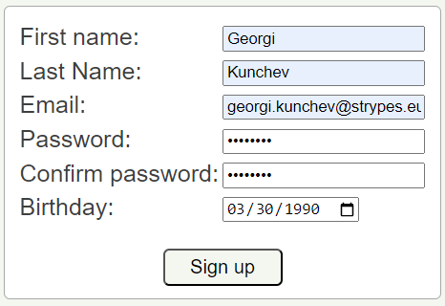

Submitting the form, you will receive a message to check your email input to verify your address and finish your registration.

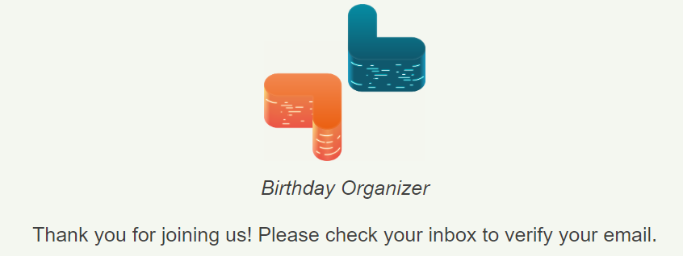

### Step 2 - Verify your email address

Click on the link you received in your email to confirm the email address.

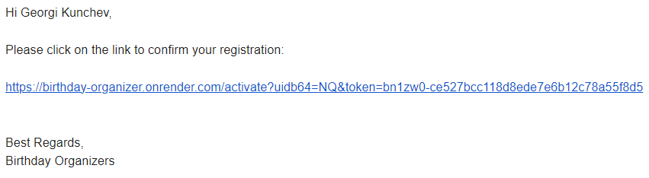

*Currently the email address used to communicate with Birthday Organizers users is [gvkunchev@gmail.com](mailto:gvkunchev@gmail.com), but as soon as we migrate to GCP, we will set up a more appropriate sender address.

You will be redirected to the confirmation screen that your account is ready to be used.

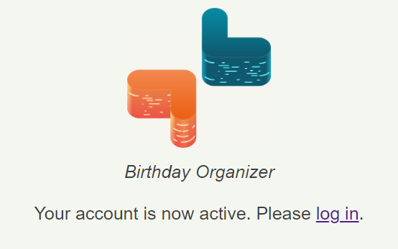

### Step 3 - Log-in

As a last step, you are ready to log in to your account, using the link in the page explained above, or navigating to the [home page](https://birthday-organizer.onrender.com/).

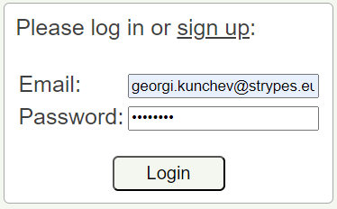

### Step 4 - Complete your account information (optional)

In case you plan to be a host to an event, receiving payments from other users, you need to supply the Birthday Organizer with your IBAN and/or Revolut information.

(The Birthday Organizer tool doesn’t make any payments itself, it just tracks payments that the users made using conventional payments methods)

Navigate to the setting page by using the button in the top-right corner.



Or, if you are using a mobile device, expand the sandwich menu, and click on “Settings”.

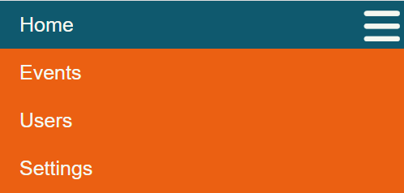

The settings menu will allow you to change your password.

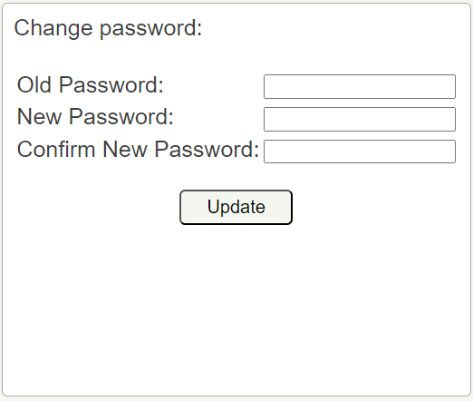

But more importantly, it allows you to enter your payments methods: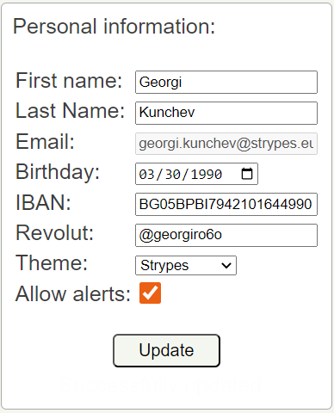

Enter your IBAN and/or Revolut information and click on “Update”.

You can also use the setting menu to change the color theme of the tool. We support five themes:

1. Strypes  
   
2. Mint Milk  
   
3. Purple Haze  
   
4. Caprese  
   
5. Night vision



You can also unselect the “Allow alerts” setting and Birthday Organizer will not send ANY email alerts to you.

# Pages

## Home page

The home page consists of a calendar, overview and dashboard and what’s-new dashboard.

### Calendar

The calendar shows dot marks for all events that you are currently part of. The legend shows what kind of event the dots correspond to.

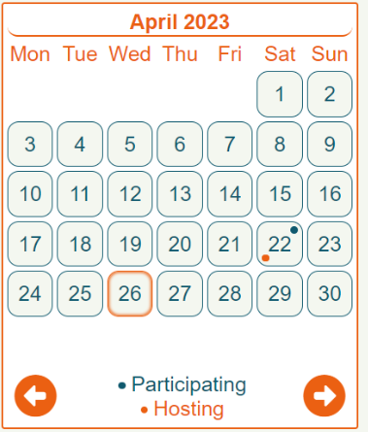

Clicking on a day from the calendar, that has events, shows a pop-up with details about the events.

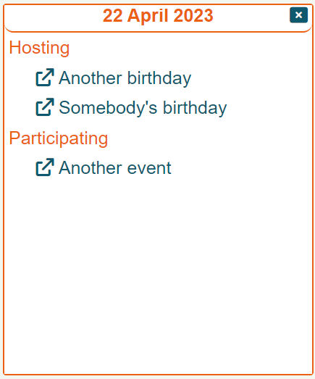

The events are separated by your role - hosting the event, or simply participating in it.

The items from the list are links to the actual event pages.

### Overview

The overview page will show everything that you need your attention.

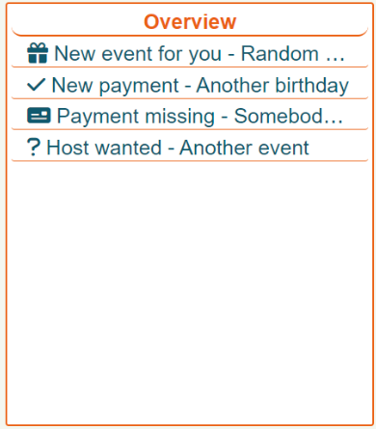

The overview page will show all events that fall into these categories:

1. Events that you are eligible for, but you are not part of them yet;
2. Events that you are hosting and have new payments awaiting your confirmation;
3. Events that you are part of, but still have no host (nobody volunteered for collecting the money);
4. Events that already have a host, but you haven’t submitted a payment.

Again, the events listed in the overview are links to the actual event page.

### What’s New

This part of the home page will show you the latest changes in the development of the tool, including bug fixes and new functionalities.

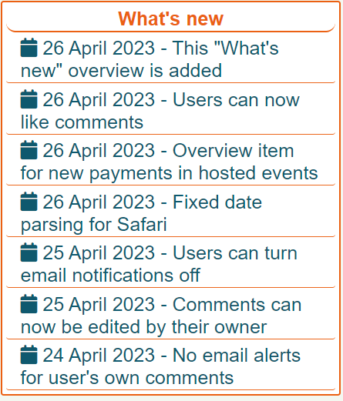

## Events page

The events page will list all events that you are eligible for, separated in three categories.

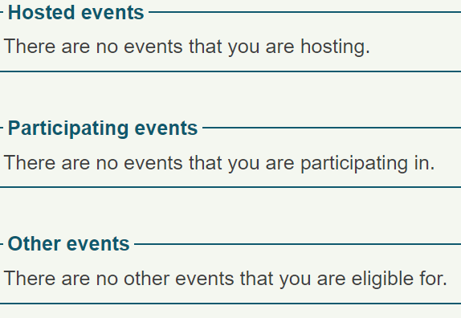

At this point, the only events that you are not eligible for is the one in which you are the celebrant - the event is for your own birthday.

The event categories are:

1. Events you are hosting (you collect the money);
2. Events you are simply participating in, but somebody else collects the money;
3. Events that you are not yet part of (you need to join the event in order to participate in the money collection and comment section).

An event that is part of any of the three categories is displayed like this:

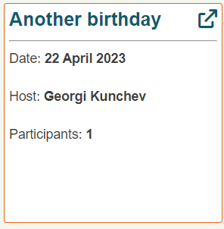

The event overview shows the name, date, host and number of participants. The top right corner shows a link to enter the actual event’s page.

Apart from the event list itself, the top right corner of the page will allow you to create an event.



Clicking on the button will show you this form.

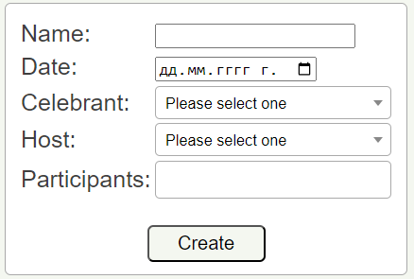

Populate all information and click on the “Create” button.

The name, date and participants fields are mandatory.  
The selection of the participants is not very convenient. We will improve on that in the future.

## Event page

Entering the page for any event, either using the link on the “Home“ page or the “Event“ page, will show you all the details for the event. This is where the real action happens.

### Header

There are three scenarios for the header of the page, based on the type of event you are in:

1. Events that you are eligible for, but not yet participating in, will show a “Join” button, allowing you to be part of the event.  
   In this case you can see the comment section and all the payments that took place, but you have no access to take any further actions.  
   
2. Events that you are part of, but have no host yet, will show the “Become host” button, which will allow you to volunteer for money collection.  
   
3. Events that you are part of, and there is already a host, will show no buttons. Instead, they will show the details for the host - payment methods that he/she filled in their account, as well as the total amount of money collected so far:  
   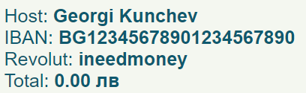  
   * The IBAN and Revolut fields are clickable and when clicked, their content will be copied to your clipboard. Mobile users that click on the Revolut field will be redirected to the Revolut app to directly make a money transfer to the corresponding user.
4. At the very bottom of the header, you can see information about the celebrant’s wishlist.  
   An empty wish list will simply show:  
     
   If the person has items in their shopping list, they will be listed as bullet points:  
   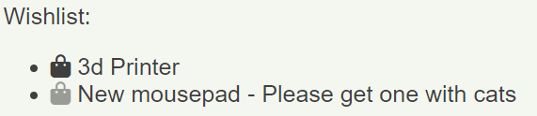  
   The host of the event can see shopping cart icons next to each item. Clicking on the icon will mark this item as “bought” and it will automatically be deactivated once the event is archived. This way the celebrant is not required to remove items that they already received. Please note that they can still reactivate a wishlist item if they want to.
5. Events that you are hosting will show the “Edit event” and “Delete event” buttons. Only hosts are allowed to perform these actions.  
     
     
   Clicking on the “Delete event” button will show a confirmation dialog:  
   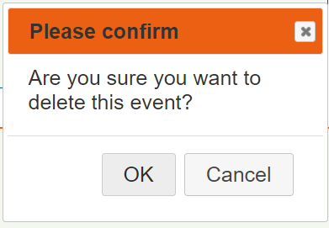  
     
   Clicking on the “Edit event” button will show you a form where you can modify all event’s fields:  
   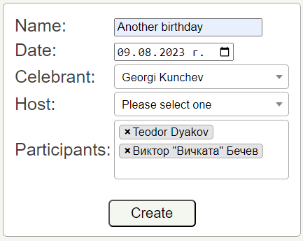
6. Events that you are hosting will show a button that will send an email to all registered users that are not yet participating in the event and share at least one circle with the celebrant. A pop-up will be shown that will ask for your confirmation that you want to perform the spam activity.  
   

### Comment section

You can post comments in the comment section, where other participants’ messages will appear.

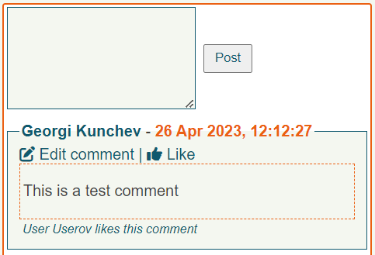

This is the section where people can discuss the present that will be bought.  
In the future, we will also include wish lists that will help pick up the present.

All comments support [Slowdown syntax](https://github.com/showdownjs/showdown/wiki/Showdown's-Markdown-syntax) which allows you to add images, links, emojis and other cool stuff.

In case the comment is your own, you can click on the ”Edit comment” button to change the content.



Once you are done, click on the “Done” button to submit the new version.

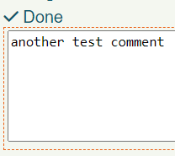

You can use the “Like” button to add a like to any comment. If you already liked the comment, the button will change to highlighted “Liked” and you can click it again to remove your like.



Any comment that already has likes will show an overview of who liked it:



### Payments section

The payment section will show all participants and their corresponding payments.

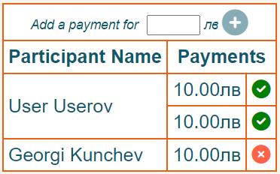

People can make more than one payment if necessary.

Every payment is first registered by the user that gives the money and then must be confirmed by the event host (the one that receives the money).  
  
When a user makes a payment that is not yet confirmed, he/she can delete it by clicking on the red cross button.  
When a payment is already confirmed, it cannot be deleted.  
* If it needs to be deleted, the host first has to revert the payment confirmation which will allow the user to delete his/hers payment.  
  
The host on the other hand will see all unconfirmed payments in a semi transparent green tick circle.



Clicking on that circle will allow him/her to confirm the payment, after which the circle is not transparent anymore:



Clicking on the circle again will allow the host to revert his confirmation.  
  
* The payments made by the host should not, and actually can not, be confirmed. The host can’t pay himself so he just registers the amount of money he/she is giving for the event. The host can remove the payment just like any other user can remove his/hers own payments.  
  
In case the logged-in user is the host, he can actually make payments on behalf of other people.

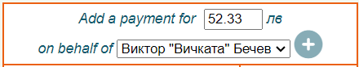

This way the host is not blocked in case a user sent him/her money, but didn’t register them on the Birthday Organizer platform. Payments created by the host on behalf of other users cannot be removed by the corresponding users. They can only be removed by the host, who added them. Such payments also don’t require confirmation by the host because they were added by him/herself.

## Users page

The user page of the Birthday Organizer will list all users that are registered on the web site.

Every user will be displayed with a box like this:

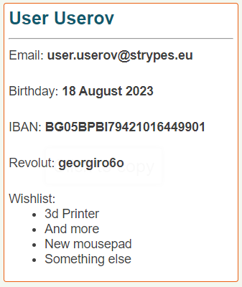

The IBAN and Revolut fields are clickable. Clicking on any of them will copy the corresponding content to your clipboard.

If you are using a mobile device, clicking on the Revolut field will actually open up your Revolut App, ready to send money to the corresponding user.

At the very bottom you can see the wishlist for the user. Only titles are presented. The description is available on mouse hover.  
  
You can use the filter input at the top to search by a specific user’s name.  


## Circles page

Circles allow registered users to only care for a subset of all users on the page. Users can freely create new circles for various groups of people. Birthday Organizer will alert you only for new events whose celebrant is in one of your circles.  
  
The page is split in two parts. Circles you are already part of…  
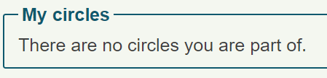

.. and circles you are not yet part of.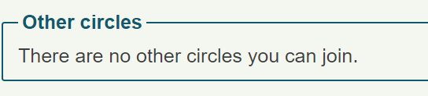

In case you are part of a circle, you can either leave the circle or edit it. Editing only allows you to change a circle’s name. Only a user can decide to join/leave a circle.  
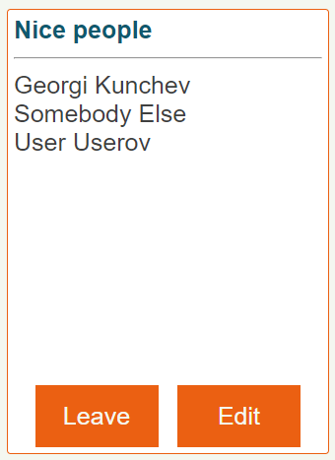  
In case you are not part of a circle, you can join it.



The “Add circle” button allows you to create a new circle.  


A circle that ends up empty is automatically deleted.

## Wishlist page

This page allows a user to help people choose a present. Using the “Add form”, you can add items to the list.  
  
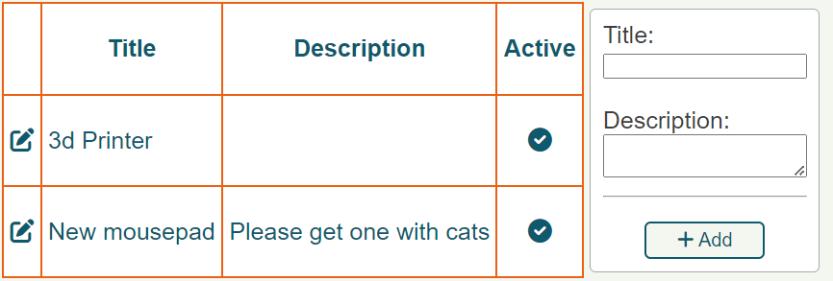  
  
If you want to edit or delete an item, click on the icon in the left column.  
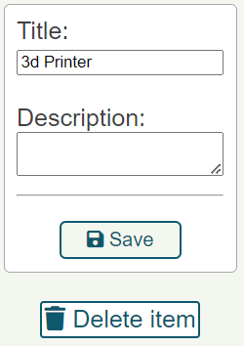  
If you want to deactivate an item, click on the corresponding icon in the last column.  
If the host of a birthday event bought you something from the wishlist, once the event for that birthday is archived (14 days after your birthday), the item will automatically become deactivated. Feel free to reactivate or deactivate Wishlist items as needed. Only active items will be presented to the participants in an event that you are a celebrant to.

# Automation

The Birthday Organizer has a list of automated tasks that help orchestrate the whole procedure.

The tasks are as follows:

1. Birthday Organizer will scan through all its users once every 24 hours to see if there are event actions that need to take place. These actions include:
   1. If a user has his/hers birthday in the next 2 weeks, Birthday Organizer will create an event for that birthday and will send an email to all users that share at least one circle with the celebrant, asking them to join the event. If the user wants to participate, it is recommended to join it right away. Birthday Organizer will not send any further emails regarding this event unless the user decides to participate.
   2. If a user has his/hers birthday in the next 2 weeks, Birthday Organizer will prompt the user to update their Wishlist with a short email. This happens simultaneously with the event creation from point “a” above.
   3. If an event that has been created has no host yet, Birthday Organizer will send an email to all participants, asking them to volunteer and become a host. This will happen once every 24 hours, until a host has been found. No emails will be sent to users that haven’t joined the event.
   4. If an event’s date (normally the birthday of the celebrant) is more than two weeks in the past, Birthday Organizer will archive the event, removing any records for it from all pages in the tool. The event, however, still lives in the database, so in case of urgent needs, the administrators can unarchive it, modify it or simply read information for it.
2. Birthday Organizer will scan through all events once every hour and will look for new comments. In case there is a new comment, Birthday Organizer will send an email to all participants, alerting them of the new activity. No matter if the user has already been on the event page and maybe already saw the comments, the email is sent. In the future, we might want to improve on that, but so far this is just like using the emails so it qualifies as an MVP implementation of the needed feature.

# Interface

Birthday Organizer aims to provide a useful interface for both desktop and mobile.  
All pages are completely mobile friendly and scale to fit your device, allowing you to organize birthdays on the go.  
In case there is a problem on your device or you want to suggest an improvement, feel free to contact the developers. We will be happy to improve.  
We decided to go with a single web interface for all platforms, as opposed to creating separate Mobile Apps, simply because it allows rapid development and easier maintenance. At this point there are on plans on creating mobile applications, but in case you want to volunteer for creating such an app, we will be happy to give you code access and let you do it.

# Developers/Administrators

The tool has been developed by:

[Georgi Kunchev](mailto:georgi.kunchev@asml.com) [Stanislav Stoev](mailto:stanislav.stoev@strypes.eu) [Teodor Dyakov](mailto:teodor.dyakov@strypes.eu) [Viktor Bechev](mailto:viktor.bechev@strypes.eu)  
  
It started as a pet project in the beginning of 2022.  
It was Alpha tested in GCP during March of 2023.

It was Beta tested in render.com starting April 2023.

Future plans include migrating to GCP, improving the interface and the features of the tool, as well as creating circles (separate teams) so that the tool can be broadcasted to the whole Strypes Group and individual teams or groups of friends can create isolated circles among which the events are created.

# Support

Contact the developers listed in the section above to suggest improvements, report a bug, or even if you want to join the developers club.  
In the future, the email responsible for sending emails from the tool will probably be used as an official support input as well.

# Technical Details

The product is developed using the following technologies.

* Kubernetes
* Docker
* Apache
* Python
* Django
* PostgreSQL
* Redis
* Celery
* Yagmail
* Whitenoise
* HTML
* JavaScript
* jQuery
* CSS
* SASS
* Font Awesome

The deployment is automated with YAML scripts that allow automatic deployment at GCP and a Dockerfile for automatic deployment at render.com (and probably any other similar platform).  
  
Deploying in GCP is fully automated and documented in README.md of the repository.  
Deploying new versions requires manual triggers from the CLI.  
  
Deploying on render.com requires manually setting up the database and environment, but then it includes ready to go CI/CD by connecting render.com with GitHub. Pushing to GitHub automatically updates the production environment.

The tool is set up so that everything (except sending emails) can be started and tested locally for development. Simply start the Django development server and the tool is live with a local temporary SQLite database.  
  
The tool is under version control at  
<https://github.com/gvkunchev/birthday_organizer>  
which is a private repository, but I am including it here for the record.